JULIANA SILVA
FASHION DESIGNER

ABOUT ME EDUCATION

Let me introduce myself, I am a fashion designer who has 7 years of experience in this job. I am very experienced in various fashion styles for all seasons and I have made various models for men and
2020 - 2022 Fashion School
Aldenaire University

Already made all the styles for all seasons and made all the designs to be more sold.

women for a world famous brand.

CONTACT
 +123-456-7890

 hello@reallygreatsite.com www.reallygreatsite.com
2020 - 2022
Fashion School Aldenaire University
Already made all the styles for all seasons and made all the designs to be more sold.


123 Anywhere St., Any City, ST

EXPERIENCE


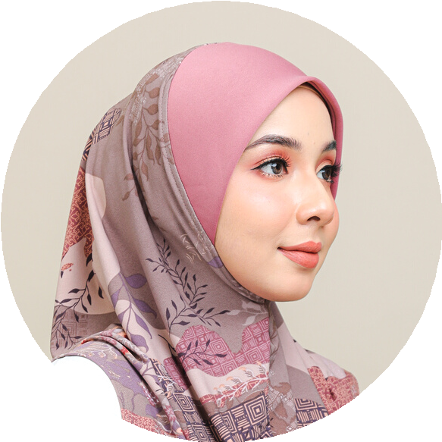12345

PERSONAL SKILLS
Professional Teamwork Flexibility
Creativity Organitation
2020 - 2022

2020 - 2022
Salford Company Fashion Manager
Already made all the styles for all seasons and made all the designs to be more sold.

Salford Company Fashion Manager
Already made all the styles for all seasons and made all the designs to be more sold.

